Sample Software Architecture Document

Product Warehouse Inventory Management

Table of Contents

1. Introduction 3
1.1 Purpose 3
1.2 Overview 3
1.3 Tools and Technologies 3
2. Logical View 4
3. Model Design 4
4. Deployment View 5
5. Web Service Interfaces 6

Introduction
This document provides a high-level overview and explains the technical design of Product Warehouse Inventory Management application. The proposed application will expose its functionality through RESTful interfaces.

Purpose
The document provides a comprehensive technical design of application. It includes logical design, implementation and deployment view.

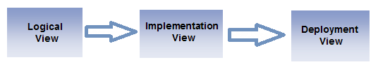

Overview

Following are the key points from functional requirements of proposed application.
- Company have offices in multiple counties.
- Each office has many warehouses.
- Company sells different products from its two Brands.
- Products can of different types (Products, Components, Package Material).
- Products also can have different size.
- Application should provide a way to set/view inventory of product in single warehouse, all warehouses in office and all warehouses in company.
- Application support adding new warehouses, products and offices.

Following are technical requirements for application:
- Application should be developed using Java 8, Maven, Spring, Hibernate.
- MySQL 5 should be used as database
- Application should support deployment in Apache Tomcat 8.
- Application should be tested using Unit tests and Integration Tests.

Tools and Technologies
This application will be setup using Spring Boot 5.1.x framework. This framework will use following framework and tools
- Hibernate
- Spring Framework
- Maven
- Apache Tomcat 8 (embeded)
- Junit

Logical View

The application is divided into layers based on the 3-tier architecture. The layering model of the online catering application is based on a responsibility layering strategy that associates each layer with particular responsibility.
This strategy has been chosen because it isolates various system responsibilities from one another, so that it improves both system development and maintenance.
Each layer has specific responsibilities.
- The Data Access Layer provide the interfaces necessary to communication with database. This layer is implemented in com.inventory.management.dao package. In this Hibernate is used to communicate with database
- The services Layer uses the Data Access Layer and provides the interfaces to be used by Controller Layer. This Layer implements business rules. com.inventory.management.services package will contain all services.
- The controller layer exposes RESTful services to be used by client applications. This layer will use services from Services Layer.
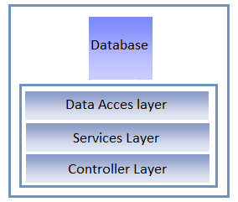

Model Design

Application model will contain following core entities:
- Country
- Office
- Warehouse
- Product
- ProductSize
- Inventory
- Brand
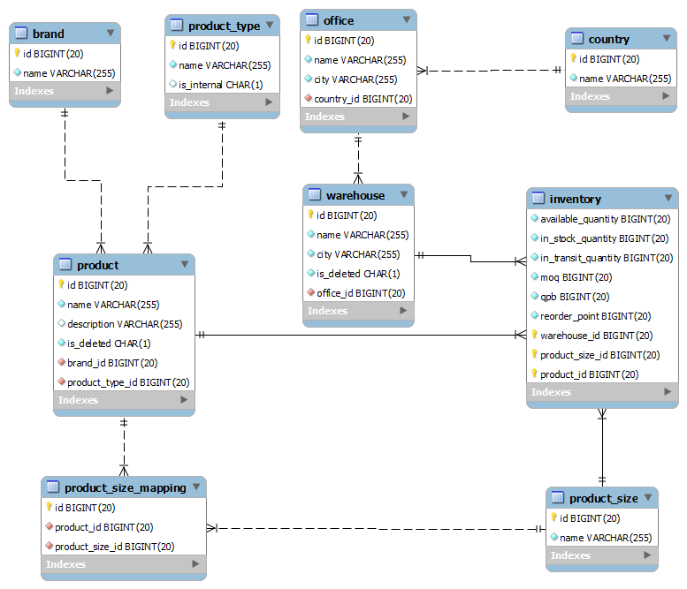

Deployment View
Application deployment environment will contain following components:
- MySQL 5 database
- Apache Tomcat 8
- Web Services will be exposed over internet/network.

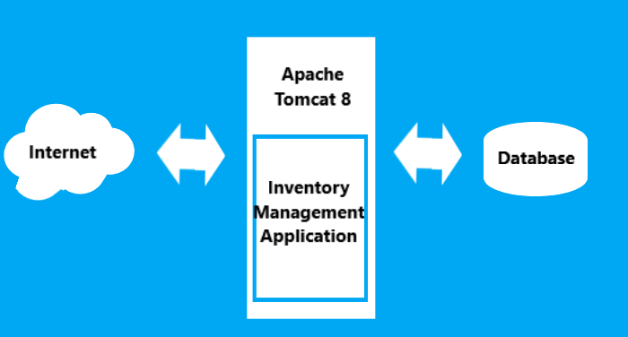

Web Service Interfaces

Following RESTful webservices will be exposed by application

Office Web Services
Service | URL | Request Body | Method | Response (Json)
View all offices | /office/list |  | GET | Returns list of offices in company
View office details | /office/view/{officeId} |  | GET | Returns office info.
View office in a country | /office/view/country/{countryIdOrName} |  | GET | Returns office info.
View all warehouses in office | /office/{officeId}/view/warehouse |  | GET | Returns list of warehouses.
Add new office | /office/new | Office | POST | Returns newly created office.
Product Size Web Services
View all sizes | /size/list |  | GET | Returns list of product sizes
View sizes of product | /size/product/{productId} |  | GET | Returns list of product sizes
Associate size with product | /size/add/product/{productId} | ProductSize | PUT | Returns office info.
Edit ProductSize | /size/ edit/{productSizeId} | ProductSize | PUT | Returns updated Entity.
Add new ProductSize | /size/new | ProductSize | POST | Returns newly created size.
Warehouse Web Services
View all warehouses | /warehouse/list |  | GET | Returns list of warehouses
View warehouse | /warehouse/view/{warehouseId} |  | GET | Returns warehouse
Delete Warehouse | /warehouse/delete/{warehouseId} |  | PUT | Returns deleted warehouse.
Edit Warehouse | /warehouse/edit/{warehouseId} | Warehouse | PUT | Returns updated Entity.
Add new Warehouse | /warehouse/new | Warehouse | POST | Returns newly created warehouse.
Product Web Services
View all products | /product/list |  | GET | Returns list of all products
View Product | /product/view/{productId} |  | GET | Returns Product
Delete Product | /product/delete/{productId} |  | PUT | Returns deleted Product.
Edit Product | /product/edit/{productId} | Warehouse | PUT | Returns updated Entity.
Add new Product | /product/new | Warehouse | POST | Returns newly created Product.
Inventory Web Services
View Product Inventory in all warehouses | /inventory/product/{productId} |  | GET | Returns list of inventory info.
View Product Inventory in a warehouse | /inventory//warehouse/{warehouseId}/product/{productId} |  | GET | Returns list of inventory info.
View Product Inventory in an office | /inventory/office/{officeId}/product/{productId} |  | GET | Returns list of inventory info.
Update inventory of product in a warehouse | /inventory/set/warehouse/{warehouseId} | InventoryRestDto should contain product and its inventory info. | PUT | Returns updated inventories.
Update inventory of product in an office | /inventory/set/office/{officeId} | InventoryRestDto should contain product and its inventory info. | PUT | Returns updated inventories.
Update inventory of product in all warehouses | /inventory/set/all | InventoryRestDto should contain product and its inventory info. | PUT | Returns updated inventories.

